PYQ of (Analysis and Design of Algorithms) 5 Mark

2019
a) Compare between dynamic programming approach and divide and conquer approach. Write the basic steps to develop a dynamic programming algorithm. Write the name of a problem that can be solved using dynamic programming algorithm. 2+2+1=5
b) Calculate the time complexities of quick sort in case of worst case partitioning and best case partitioning. What is the best case running time of merge sort? 2+2+1=5
c) Write the properties of a red-black tree. Insert 2, 6, 13 in the following red-black tree. [Shaded nodes are red] 2+3=5
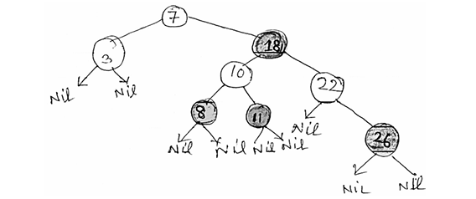
d) What is heap? Write an algorithm to construct a heap from an array of data elements. 1+4=5

2021
a) Describe depth-first search in brief with a suitable example.
b) Describe decision tree in brief with a suitable example.
c) Write a short note on Divide and Conquer technique for designing an algorithm.
d) Write an algorithm to generate the minimum spanning tree of a graph. Explain the algorithm with an example. 2.5x2=5

2022
a. Describe any one technique used for algorithmic complexity analysis in brief.
b. Analyze the average case time complexity of quick sort algorithm.
c. Describe AVL-tree formation technique in brief with at least four nodes.
d. Describe depth first search algorithm for a graph having at least four vertices.

2022-23
a) Show that log (1+1/i) = 1/I – 1/2i² + 1/3i³ – 1/4i⁴ + 1/5i⁵+ ………………….. is θ (log n).
b) Why do we use amortised analysis? Distinguish between amortised and average case analysis.
c) State some important properties of red-black tree?
d) Discuss breath first search algorithm in brief with a suitable example.

ANSWERS
2019
a) Compare dynamic programming and divide and conquer, and describe steps to develop a dynamic programming algorithm. Mention a problem solvable by dynamic programming.
Comparison:
- Dynamic Programming (DP):
  - Solves problems by breaking them into overlapping subproblems.
  - Stores solutions to subproblems to avoid redundant computations (memoization).
  - Suitable for optimization problems with optimal substructure and overlapping subproblems.
- Divide and Conquer:
  - Divides the problem into non-overlapping subproblems.
  - Solves each subproblem independently and combines their solutions.
  - Examples: Merge Sort, Quick Sort.
Steps to Develop a DP Algorithm:
- Characterize the structure of an optimal solution.
- Define the value of an optimal solution recursively in terms of the values of smaller subproblems.
- Compute the value of an optimal solution (typically in a bottom-up manner).
- Construct an optimal solution to the problem.
Example Problem:
- Fibonacci Sequence:
  - Recursive formula:
F(n)=F(n−1)+F(n−2)
DP approach involves storing previously computed Fibonacci numbers to avoid redundant calculations.

b) Calculate time complexities of quicksort in worst and best cases. What is the best case running time of mergesort?
Quick Sort:
- Worst Case:
  - Occurs when the pivot divides the array into highly unbalanced partitions (e.g., when the smallest or largest element is always chosen as the pivot).
  - Time Complexity: O(n²).
- Best Case:
  - Occurs when the pivot divides the array into two nearly equal parts.
  - Time Complexity: O(n log n).
Merge Sort:
- Best Case:
  - Merge Sort always divides the array into two halves and merges them, regardless of the initial order.
  - Time Complexity: O(n log n).

c) Write properties of a red-black tree. Insert nodes (2, 6, 13) into a given red-black tree.
Properties of a Red-Black Tree:
- Node Colors:
  - Each node is either red or black.
- Root Property:
  - The root is always black.
- Leaf Property:
  - All leaves (NIL nodes) are black.
- Red Node Property:
  - Red nodes cannot have red children (no two red nodes can be adjacent).
- Black Height Property:
  - Every path from a node to its descendant NIL nodes has the same number of black nodes.
- Balanced Height:
  - The path from the root to the farthest leaf is no more than twice as long as the path to the nearest leaf, ensuring logarithmic height.
Insertion of Nodes:
- Insert 2:
  - Inserted as a red node. If it violates any red-black properties, perform rotations and recoloring to restore properties.
- Insert 6:
  - Inserted as a red node. Adjust the tree to maintain red-black properties.
- Insert 13:
  - Inserted as a red node. Necessary rotations and recoloring are performed to maintain balance.
Note: The exact tree structure after each insertion depends on the initial configuration and may require specific rotations and recoloring steps.

d) What is a heap? Write an algorithm to construct a heap from an array of elements.
Heap:
- A heap is a complete binary tree that satisfies the heap property:
  - Max Heap: The key of each node is greater than or equal to the keys of its children.
  - Min Heap: The key of each node is less than or equal to the keys of its children.
Algorithm to Construct a Max Heap:
- Input: An array of elements.
- Build the heap from the bottom up:
  - Start from the last non-leaf node and apply the heapify operation to each node.
- Heapify Operation:
  - Compare the node with its children.
  - If the node is smaller than its largest child, swap them.
  - Recursively apply heapify to the affected subtree.
Note: The heapify operation ensures that the subtree rooted at a given node satisfies the heap property.

2021
a) Describe depth-first search (DFS) with an example.
Depth-First Search (DFS):
- Definition:
  - DFS is an algorithm for traversing or searching tree or graph data structures. It starts at the root (selecting some arbitrary node as the root in the case of a graph) and explores as far as possible along each branch before backtracking.
- Algorithm:
  - Start from the root node.
  - Mark the node as visited.
  - Visit all the adjacent nodes that have not been visited.
  - Repeat the process for each unvisited adjacent node.
- Example:
  - Consider the graph:
A -- B -- D
| |
C -- E
  - DFS traversal starting from node A: A → B → D → E → C.
b) Describe a decision tree with an example.
Decision Tree:
- Definition:
  - A decision tree is a flowchart-like structure where each internal node represents a "test" or "decision" on an attribute, each branch represents the outcome of the test, and each leaf node represents a class label or decision outcome.
- Example:
  - In a decision tree for loan approval:
Is credit score > 700?
/ \
Yes No
| |
Approved Denied
- This tree helps in making decisions based on the credit score.
c) Write a short note on the divide and conquer technique.
Divide and Conquer:
- Definition:
  - Divide and Conquer is an algorithm design paradigm that involves three steps:
    - Divide: Break the problem into smaller subproblems.
    - Conquer: Solve the subproblems recursively.
    - Combine: Merge the solutions of the subproblems to solve the original problem.
- Examples:
  - Merge Sort, Quick Sort, Binary Search.
d) Write an algorithm to generate a minimum spanning tree of a graph and explain with an example.
Prim’s Algorithm (MST):
- Start with any node (say A) and mark it as visited.
- Find the edge with the minimum weight that connects a visited node to an unvisited node.
- Add the selected edge and the unvisited node to the MST.
- Repeat until all nodes are visited.
Example:
Graph:
A --(1)-- B
| |
(3) (2)
| |
C --(4)-- D
Steps:
- Start with A → Pick edge A-B (1)
- From A or B, pick edge B-D (2)
- From A, B, D → pick edge A-C (3)
- MST Edges: A-B, B-D, A-C
- Total weight = 1 + 2 + 3 = 6

2022
a) Describe one technique for algorithmic complexity analysis.
Asymptotic Analysis:
- Analyzes the growth of running time with respect to input size (n).
- Ignores machine-specific constants.
- Uses notations like:
  - Big-O (O): Upper bound (worst case)
  - Theta (Θ): Tight bound (average case)
  - Omega (Ω): Lower bound (best case)
- Example: For a loop running n times, complexity is O(n).

b) Analyze the average case time complexity of quicksort.
Quick Sort Average Case:
- In average case, the pivot divides the array into two nearly equal halves.
- Time Complexity:
T(n)=2T(n/2)+O(n)
- Solving the recurrence:
T(n)=O(nlogn)
- So, average case time complexity is O(n log n).

c) Describe AVL-tree formation with at least four nodes.
AVL Tree:
- A self-balancing binary search tree where the height difference (balance factor) of left and right subtrees is at most 1 for every node.

Example Insertion:
Insert nodes: 30, 20, 10, 25
- Insert 30 → root
- Insert 20 → left of 30
- Insert 10 → left of 20 → imbalance at 30 (Left-Left case)
- Perform Right Rotation on 30
- Insert 25 → right of 20 → tree remains balanced
Final Tree:
20
/ \
10 30
/
25

d) Describe the depth-first search algorithm for a graph with at least four vertices.
DFS Algorithm:
- Start at a node and mark it visited.
- Recursively visit each unvisited neighbor.
- Backtrack when no unvisited neighbors are left.
Example Graph:
A -- B
| |
C -- D
DFS starting from A:
- A → B → D → C
Visited Order: A, B, D, C

2022–23
a) Show that log(1+1/i) = 1/i – 1/2i² + 1/3i³ – 1/4i⁴ + ... is θ(log n).
Proof Sketch:
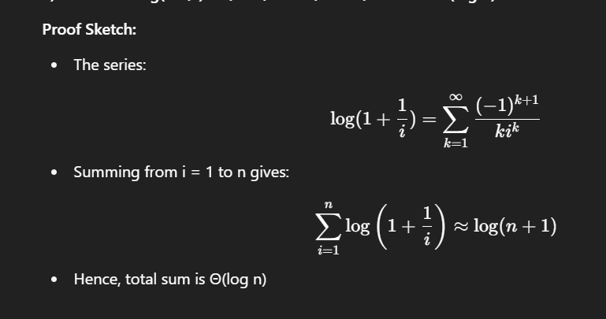

b) Why do we use amortized analysis? Distinguish between amortized and average case analysis.
Amortized Analysis:
- Used to analyze the average cost per operation over a sequence of operations.
Difference:
Feature | Amortized Analysis | Average Case Analysis
Input Dependence | Worst-case sequence | Average over all inputs
Use Case | Stack with dynamic array | Random input behavior
Cost per op | Over a sequence | Expected over distribution

c) State some important properties of a red-black tree.
Red-Black Tree Properties:
- Each node is either red or black.
- The root is always black.
- No two red nodes appear consecutively on a path.
- Every path from a node to descendant leaves has same number of black nodes.
- Red-black tree maintains a balanced height (O(log n)).

d) Discuss breadth-first search (BFS) algorithm with an example.
BFS (Breadth-First Search):
- Definition:
A graph traversal method that explores all neighbors of a node before moving to the next level.
- Steps:
  - Start from a chosen source node.
  - Enqueue it and mark as visited.
  - While the queue is not empty:
    - Dequeue a node.
    - Visit all its unvisited neighbors.
    - Enqueue each neighbor and mark it as visited.
- Example Graph:
A
/ \
B C
/
D
- BFS starting from A:
  - Queue: [A] → Visit A
  - Queue: [B, C] → Visit B
  - Queue: [C] → Visit C
  - Queue: [D] → Visit D
- Traversal Order: A → B → C → D

